1.Stored Procedure to select employee details based on the DepartmentID.

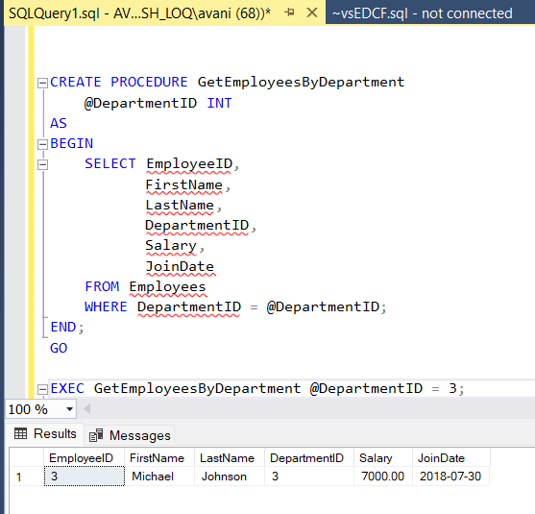

2.Stored Procedure for Inserting the Employees
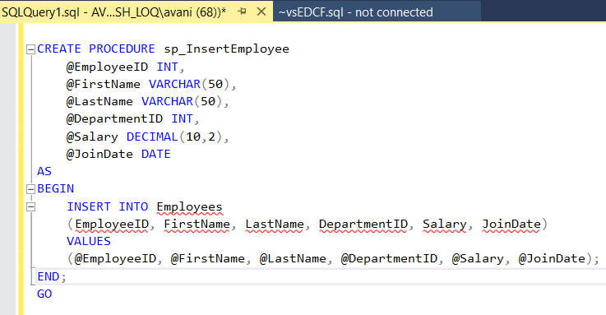
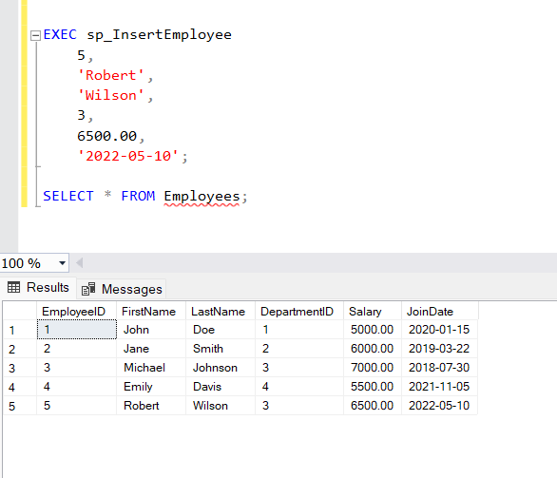

3. Return Data from a Stored Procedure
